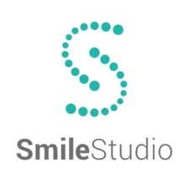
Annual Periodontal Plan

The Annual Preventative Plan is designed to help patient’s maintain good oral health while discounting the cost. Unlike most insurance plans, APP does not have a limit on your annual benefits and has no waiting periods.

This plan includes:
- Up to 4 Periodontal Cleanings
- Complete Set of X-rays
- 2 Fluoride Treatments
- 2 Comprehensive Exams
- 10% discount on all Dental Treatment
- 5% discount on all Orthodontic Treatment

Total Value= $1060.00 Your Cost=$500.00

- Exclusions and Limitations:
- Products sold in office will be discounted (i.e. Waterpik, Rinses, Oral B Spinbrushes)
- If for any reason you have not taken full advantage of the Preventative Plan, we are not responsible for extending the contract. The discount plan is good for a year from the date purchased. No Exceptions.
- This plan cannot be used at any other dental office.
- Payment in full is required at the time of treatment to receive the 10% discount.
- Third party financing may voice the 10% discount.
- The Annual Periodontal Plan cannot be used in conjunction with any other dental insurance.

_____________________________________ ______________________________________
Signature Date

