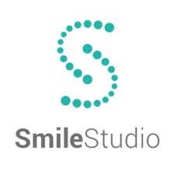
Annual Preventative Plan
The Annual Preventative Plan is designed to help patients maintain good oral health while discounting the cost. Unlike most insurance plans, APP does not put a limit on how much you can spend annually and has no waiting periods.
This Plan Includes:
- 2 Routine Prophylaxis
- Complete Set of X-rays
- 2 Fluoride Treatments
- Comprehensive Exam (Including Oral Cancer Screening)
- 10% Discount on all Dental Treatment = Unlimited Benefit
- 5% Discount on all Orthodontic Treatment
Total Value = $660.00
Cost:
- $350.00 for Adult
- $300.00 for additional family member
- $250.00 children

Exclusions and Limitations:
- Products sold in office will not be discounted (i.e. Waterpik, Rinses, Oral B Spinbrush.)
- If for any reason you have not taken full advantage of the Preventative Plan, we are not responsible for extending the contract. The discount plan is good for a year for the date purchased. No Expections.
- This Plan Cannot is used at any other dental office.
- Payment in Full is required at the time of treatment to receive the 10% discount.
- Third party financing may void the 10% discount.
- Periodontal therapy is a non-surgical gum treatment and does not take place of the prophylaxis.
- The Annual Preventative Plan cannot be used in conjunction with any other dental insurance.

____________________________________________________ _____________________
Signature Date

